REQUIRMENT ANALYSIS PHASE
1. Objective
The Requirement Analysis Phase focuses on identifying, defining, and validating the functional and technical requirements needed to develop the Medical Inventory Management application on the Salesforce platform.
This document ensures clarity of scope, system behaviour, data structure, automation needs, and performance expectations providing a strong foundation for the effective design, development, and implementation of the Medical Inventory Management System.

2. Scope of the System
The Medical Inventory Management System is designed to digitize and automate end-to-end processes involved in managing medical supplies, equipment, and stock levels within a healthcare organization.
The scope includes:
- Digital record-keeping of medical items, suppliers, and purchase orders
- Automated stock level tracking and low-inventory alerts
- Purchase order generation and vendor management
- Dashboard and report-based analytics for real-time monitoring
- Secure, role-based access for Admin, Staff, and Inventory Managers
3. Functional Requirements
3.1 Core Functional Modules
Module | Functionality | Salesforce Feature Used
Item Catalog | Maintain master data for medical items (name, category, UOM, min/max levels) | Custom Object, Validation Rules, Record Types
Supplier/Vendor Management | Store vendor profiles, contacts, terms, and ratings | Custom Object, Related Contacts, Reports
Purchase Orders (PO) | Create/approve POs; auto-generate PO IDs; track statuses (Draft→Approved→Received/Closed) | Custom Object, Flow, Approval Process, Email Alert
Goods Receipt (GRN) | Receive items against PO; capture batch/lot, MRP, expiry, quantity received/short | Custom Object, Flow (Screen Flow), Validation Rules
Inventory & Stock Ledger | Real-time stock updates by location/store; FIFO/LIFO issue basis | Custom Object, Roll-Up (DLRS if needed), Apex (if required)
Batch/Lot & Expiry Tracking | Track batch numbers and expiry dates; prevent issuing expired items | Custom Object, Validation Rules, Scheduled Flow
Reorder & Low-Stock Alerts | Auto-alert when stock falls below reorder level; suggest reorder qty | Flow, Email Alert, In-App Notification
Issue/Consumption | Issue items to departments/wards/patients; capture usage | Custom Object, Screen Flow, QR/Barcode field
Returns & Adjustments | Handle returns, damages, and cycle count adjustments with reason codes | Custom Object, Flow, Validation Rules
Barcoding/Scanning (Optional) | Scan barcodes for fast receiving/issuing | Mobile App, QR/Barcode fields, Screen Flow
Dashboard & Analytics | Visibility into stock value, near-expiry items, top-moving items, PO cycle time | Reports, Dashboards
Security & Access | Role-based access for Admin, Inventory Manager, Store Staff, Finance | Profiles, Permission Sets, Sharing Rules
Audit & Compliance | Field history for stock changes, approvals, and adjustments | Field History Tracking, Audit Trail

3.2 System Workflow (Process Flow)
- Setup: Admin creates Item Catalog and Supplier records, defining UOM and min/max/reorder levels.
- Procurement: Inventory Manager creates a Purchase Order; Approval Process routes it to approvers.
- Receiving (GRN): Store receives items against the PO; user records batch/lot, expiry, quantity, and MRP via Screen Flow—stock updates automatically.
- Quality/Quarantine (Optional): Items can be placed in a quarantine status until QA approval; only then are they added to available stock.
- Issuance/Consumption: Departments/wards request items; Store issues stock (prefer near-expiry first). Consumption is logged for traceability.
- Reorder & Alerts: Scheduled Flows check stock levels and expiry dates; low-stock and near-expiry alerts go to Inventory Manager.
- Adjustments/Returns: Damaged/expired returns and cycle count adjustments are recorded with reasons; approvals applied if needed.
- Analytics: Dashboards update in real time to show stock valuation, PO status, top movers, near-expiry items, and monthly consumption trends.

4. Technical Requirements
Category | Requirement | Description
Platform | Salesforce Developer Edition | CRM cloud for automation
Programming | Apex (if needed) | Auto constraints & validation
Automation | Salesforce Flow | Auto rent reminder & renewal alerts
Database | Salesforce Objects | Property, Tenant, Lease, Payment
Visualization | Dashboard Builder | Rent status, lease expiry chart
Security | Profiles & Roles | Owner, Tenant, Admin access control

4.1 Software Tools Used
- Salesforce Lightning Experience
- Flow Builder
- Schema Builder
- Reports & Dashboards
- Developer Console
- Data Import Wizard (for bulk item/vendor uploads)
- Setup Audit Trail (for compliance tracking)
4.2 Hardware Requirements
Component | Minimum Requirement
Processor | Intel i3 or above
RAM | 4 GB+
Internet | Min 2 Mbps stable connection
Storage | 500 MB browser cache
Browser | Chrome / Edge latest

5. Non-Functional Requirements
Category | Requirement | Description
Performance | System must support 500+ active stock items and 100+ daily transactions | Handled efficiently through Salesforce’s multi-object architecture and optimized Flows
Security | Role-based access control | Users (Admin, Store Staff, Finance) can access only authorized modules and data; patient-related info secured
Usability | Simple UI for non-technical users | Designed using Salesforce Lightning App Builder with easy navigation and guided Screen Flows
Scalability | Support for multi-location inventory | Dynamic object relationships allow tracking by multiple stores, wards, or hospitals
Reliability | 99.9% uptime | Ensured by Salesforce’s secure and redundant cloud infrastructure
Maintainability | Low-code, easily modifiable system | Flow-based automation and configuration-driven logic reduce Apex dependency
Auditability | Full change tracking | Field History Tracking and Audit Trail enabled for stock, purchase, and adjustment records

6. Data Model Design
Object | Key Fields (examples) | Relationship Type
Item (Product Master) | Name, Category, UOM, Reorder_Level__c, Min_Level__c, Max_Level__c, Active__c | —
Supplier (Vendor) | Name, Contact_Person__c, Phone, Email, Payment_Terms__c, Rating__c | —
Inventory Location | Name, Type (Main Store/Ward/Pharmacy), Address__c, Active__c | —
Purchase Order (PO) | AutoNumber PO-{0000}, Supplier__c, PO_Date__c, Status__c (Draft/Approved/Received/Closed) | Lookup to Supplier
PO Line Item | Item__c, Quantity__c, Unit_Price__c, Tax__c, Amount__c (formula) | Master-Detail to Purchase Order, Lookup to Item
Goods Receipt (GRN) | GRN_Number__c, PO__c, Received_Date__c, Status__c (Partial/Complete) | Lookup to Purchase Order
GR Line (Batch/Lot) | Item__c, Batch_No__c, Expiry_Date__c, Quantity_Received__c, MRP__c | Master-Detail to Goods Receipt, Lookup to Item
Stock Ledger (Transactions) | Item__c, Location__c, Txn_Type__c (GRN/ISSUE/ADJ/RETURN), Qty_In__c, Qty_Out__c, Reference__c | Lookup to Item, Lookup to Inventory Location
Issue (Header) | Issue_No__c, Location__c, Department__c / Patient__c, Issue_Date__c | Lookup to Inventory Location
Issue Line | Item__c, Quantity__c, Batch_No__c (optional), Remarks__c | Master-Detail to Issue, Lookup to Item
Return/Adjustment | Type__c (Return/Damage/CycleCount), Item__c, Location__c, Quantity__c, Reason__c | Lookup to Item, Lookup to Inventory Location

Example Formula Fields
PO Line Amount (on PO Line Item)
Amount__c = Quantity__c * Unit_Price__c

PO Total (on Purchase Order, Roll-Up Summary)
Sum over child PO Line Item → Amount__c

Days to Expiry (on GR Line)
Days_to_Expiry__c = Expiry_Date__c - TODAY()

Near Expiry (Checkbox) (on GR Line)
Near_Expiry__c = (Expiry_Date__c - TODAY()) <= 30

Stock on Hand (per Item per Location)
If you keep Stock Ledger totals on a helper object or Item–Location junction:
On_Hand__c = Qty_In_Total__c - Qty_Out_Total__c (via roll-ups / DLRS)

Suggested Reorder Quantity (on Item, informational)
Suggested_Reorder_Qty__c = MAX(0, Reorder_Level__c - Current_Stock__c)

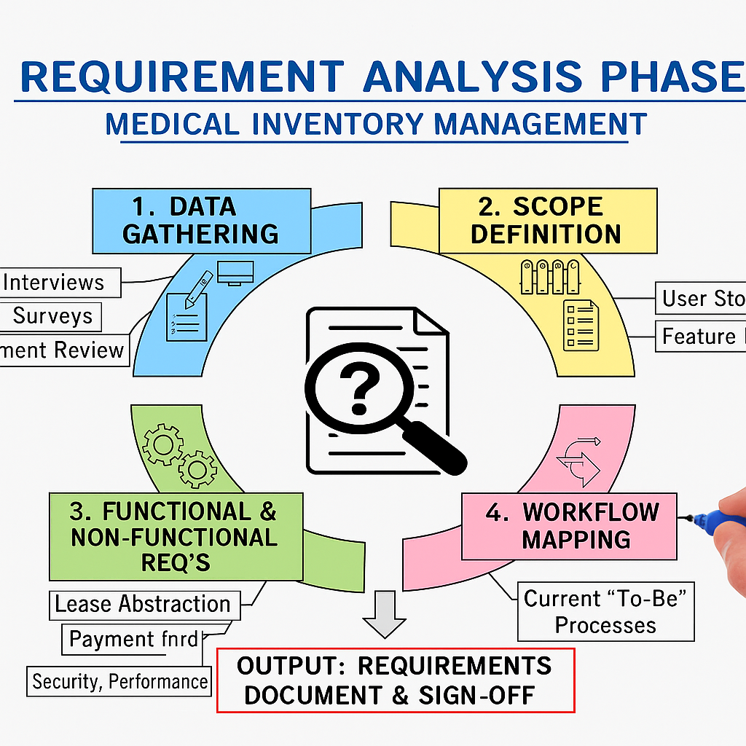
7. User Interface (UI) Requirements
Navigation tabs (Salesforce Lightning App):
- Items (Catalog)
- Suppliers
- Purchase Orders
- Goods Receipts (GRN)
- Inventory (Stock Ledger)
- Issues (Department/Patient)
- Returns & Adjustments
- Locations (Stores/Wards)
- Reports & Dashboards
- Alerts (Low-Stock / Near-Expiry)

7.1 UI Expectations

- One-click Create PO from Item or Supplier; auto-calculate Line Amount, Taxes, PO Total.
- Guided Screen Flows for GRN and Issue with optional barcode/QR input and quick actions (Receive, Issue, Adjust).
- Status indicators/badges:
- PO: Draft / Approved / Received / Closed
- Stock: In-Stock / Low / Critical (based on thresholds)
- Expiry: Days to Expiry, Near-Expiry flag
- Issue: Pending / Completed
- Mobile-friendly layouts (Salesforce mobile): compact forms, pinned list views, and quick actions on record headers.
- Home page dashboard embed with KPIs: On-hand Value, Low-Stock Count, Near-Expiry Items, POs Pending Approval, Top Movers.
- List view enhancements: conditional highlighting (e.g., red for ≤0 stock / expired), inline edit, filters by Location, Category, Status.
- Record page design: Dynamic Forms, key related lists (Lines, Batches, Movements) above the fold; utility bar for Alerts and Scanner.
- Defaults & validation in UI: default Location/UOM, prevent issuing expired or negative stock, show remaining quantity against PO.
- Accessibility: clear labels/tooltips, keyboard navigation, high-contrast icons for color-blind friendliness.

8. System Validation Requirements
Test Area | Description | Expected Result
Flow Execution | Automatic low-stock and expiry alerts triggered daily via Scheduled Flow | Email / In-App notification sent to Inventory Manager
Reorder Alert Validation | When item stock falls below reorder level | Alert generated and logged in “Alerts” object
Purchase Order Automation | Auto PO number generation and approval routing | PO number auto-generated and status updates from Draft → Approved
Goods Receipt Validation | GRN records items correctly against PO and updates stock quantity | Stock ledger updated; status changes to Received / Closed
Expiry Validation | Prevent issuing expired items | Validation rule blocks transaction and shows error message
Dashboard Validation | Stock levels, PO summary, and near-expiry chart | Dashboards auto-refresh with latest data
Permission Test | Role-based visibility across modules | Store staff sees only assigned location; admin sees all data

9. Risk Identification & Mitigation
Risk | Description | Mitigation
Data Loss | Records or files (e.g., invoices, GRN docs) deleted accidentally | Enable Salesforce Recycle Bin; schedule weekly data export/backup
Wrong Access | Unauthorized users view/edit restricted data | Enforce Profiles, Permission Sets, and Sharing Rules
Duplicate Records | Same item or supplier added multiple times | Add duplicate rules and validation logic
Stock Inaccuracy | Manual entry errors during GRN or Issue | Use validation rules and Screen Flows with guided input
Automation Failure | Flow or approval errors stop critical operations | Add error handling, debug logs, and Apex test coverage
Compliance Risk | Expired or untraceable batch issued | Implement batch-level expiry validation and audit reports
Network or Connectivity Issues | Users unable to access cloud app | Ensure offline documentation and retry logic for imports/exports

10. Summary
The Requirement Analysis Phase establishes a complete blueprint for the Medical Inventory Management System.It documents the functional, technical, data, and validation requirements, ensuring a smooth transition into the system design and development phases.
The Key achievements of this phase:
- Defined all core modules such as Item Management, Purchase Orders, Inventory Tracking, and Alerts
- Mapped the complete data model and object relationships across all Salesforce objects
- Established user interface layouts, dashboards, and automation flows for business efficiency
- Outlined validation, security, and performance standards for reliability
- Identified potential risks and documented mitigation strategies

This phase ensures that the Medical Inventory Management project is clear, well-structured, scalable, and implementation-ready within the Salesforce environment.

